Yasmin Madjidi Jeroo Final Project

**Lab Goal:** This lab was designed to test your abilities to use Jeroo. You must determine how and when to turn, when to stop, and how to keep your Jeroo out of the nets.

**Lab Description:** This lab requires that you use looping with if statements. Your Jeroo must make its way through the entire maze by picking up flowers and planting them in the nets and stop before jumping into the water.

|  |
| --- |
| **Files Needed:**  **YasminMadjidiJerooFinal.jev**  **YasminMadjidiJerooFinalTemplate.jsc** |

**Starting Screen:**

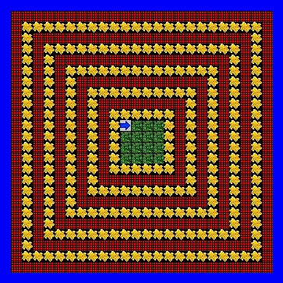

**Ending Screen:**

